GitHub : https://github.com/mankumarbhalodiya/Digital-Signal-and-Image-Processing
AIM : Simulate Hit or Miss Transformation on images.
Theory: The Hit or Miss transformation is a morphological operation used to detect specific patterns or shapes in an image. It is commonly used for shape recognition or pattern matching.
The operation requires two structuring elements: one for foreground (hits) and another for background (misses). The foreground structuring element represents the desired pattern to be matched, while the background structuring element represents the complement of the pattern.
During the transformation, the foreground structuring element is matched against the foreground pixels in the image, and the background structuring element is matched against the background pixels. Only those pixels that match both structuring elements are considered hits.

Code :
import cv2
import numpy as np
from google.colab.patches import cv2_imshow
image = cv2.imread('/content/images.jpeg', 0)
pattern = np.array([[-1, 1, -1],
[1, 1, 1],
[-1, 1, -1]], dtype=np.int8)
result = cv2.morphologyEx(image, cv2.MORPH_HITMISS, pattern)
cv2_imshow(image)
cv2_imshow(result)
cv2.waitKey(0)
cv2.destroyAllWindows()

Output :
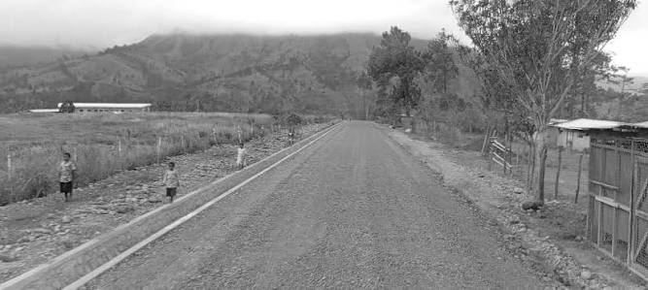
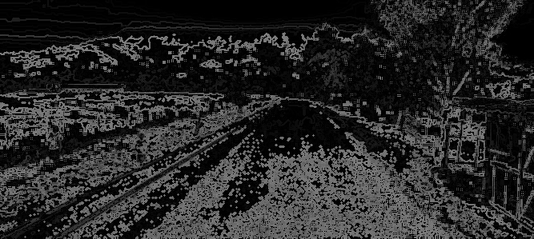

pattern1 = np.array([[1, 1, -1],
[1, -1, -1],
[-1, -1, -1]], dtype=np.int8)
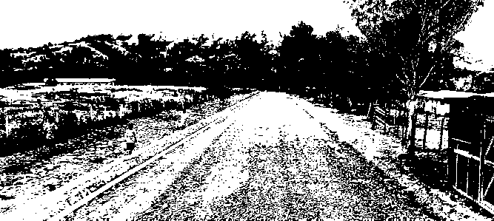
pattern2 = np.array([[-1, -1, 1],
[-1, 1, -1],
[1, -1, -1]], dtype=np.int8)


